5 different games under Catapult category

1. **Catapult 2: Siege throwing hit**

**By BYV**

Rating: 4.2

Downloads: 1Cr+

Rated: 7+

Last Updated 22 June 2023

Both Multiplayer and Single Player

Too many ads

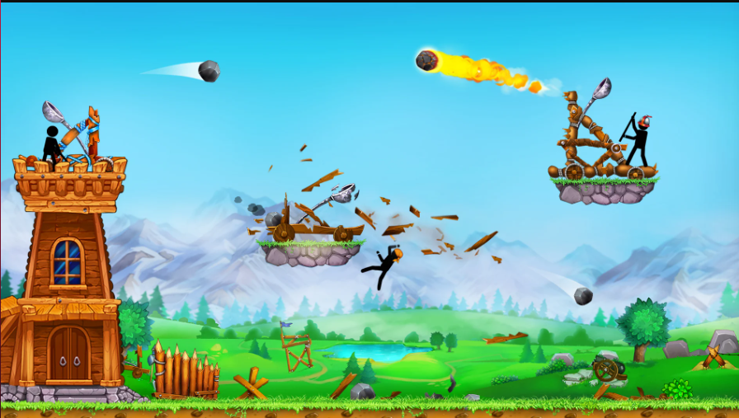

1. **The Catapult: Stickman Pirates**

**By BYV**

Rated: 4.0

Downloads: 1Cr+

Rated: 12+

Last Updated: 28 October 2022

Singleplayer, stylized

Control issues in accuracy.

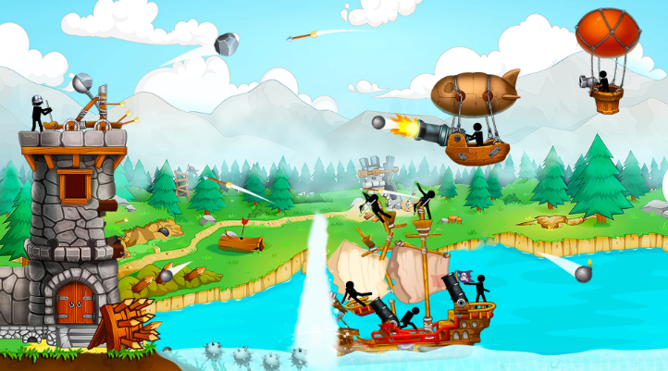

1. **Catapult Quest**

**By mobirix**

Rated: 3.9

Downloads: 1Cr+

Rated:3+

Last Updated: 15 August 2023

Puzzle, Physics, Single player

People like it for time pass a lot

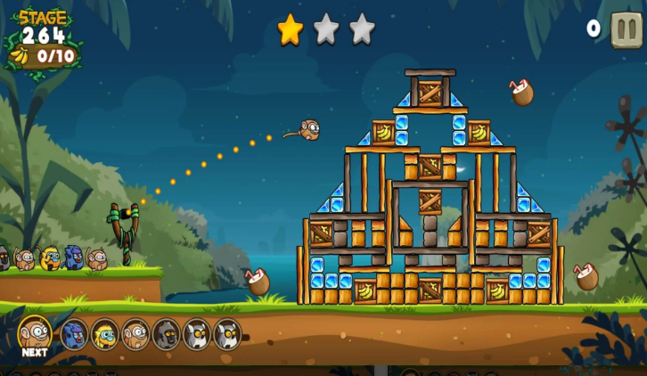

1. **Catapult Wars**

**By Brain Vault**

Rated: 3.9

Downloads: 10L+

Rated 7+

Last Updated: 21 November 2018

Artillery Shooter

So far, has over 900 levels, easy to play.

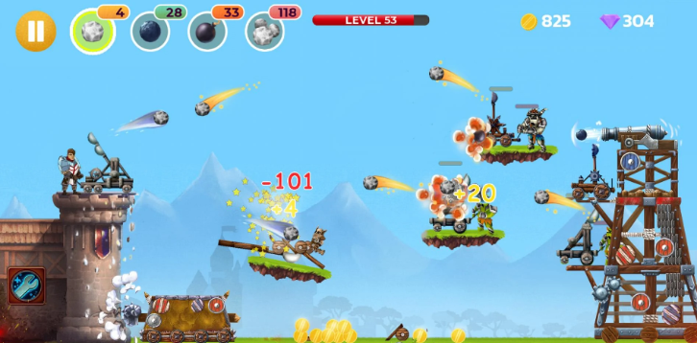

1. **Catapult 3D: Destroy The Castle**

**By EnergyLite**

Rated: 3.9

Downloads 1L+

Rated:3+

Last Updated: 28 November 2020

Physics, Puzzle

Causes battery issues and a lot of ads.

